UNIVARIATE ANALYSIS
-- This is analyzing the characteristics of a single column/variable.
-- First you separate numerical and categorical columns
SEPARATE NUMERICAL AND CATEGORICAL VARIABLES
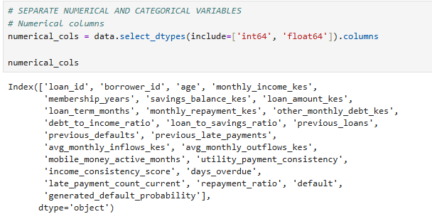
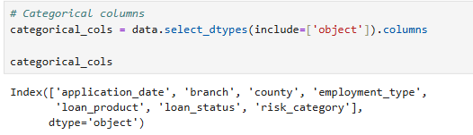

NUMERICAL UNIVARIATE ANALYSIS
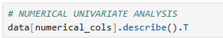
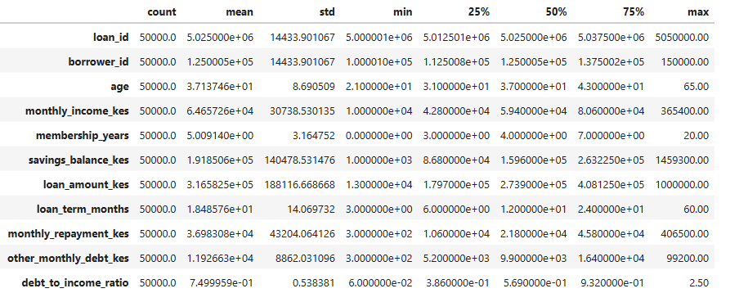

CATEGORICAL UNIVARIATE ANALYSIS
